**How to create Spring boot project**

There are 3 ways to create a spring boot project. 2nd and 3rd way is preferable.

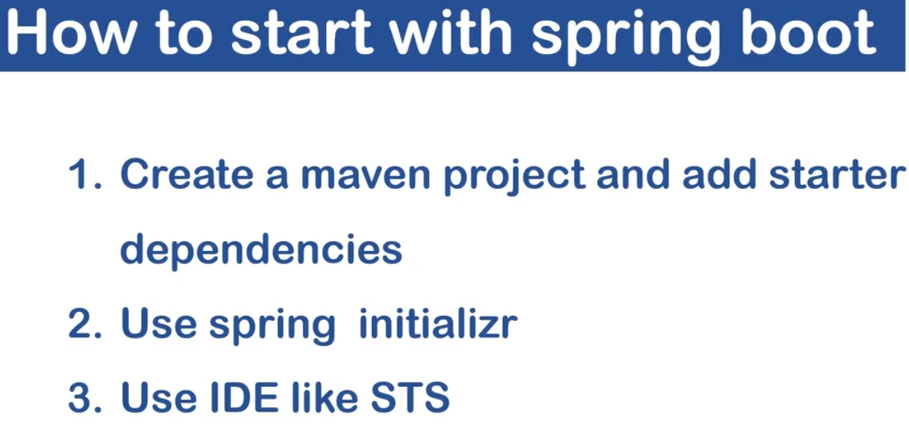

New-->Spring Starter Project🡪 New Window Appears

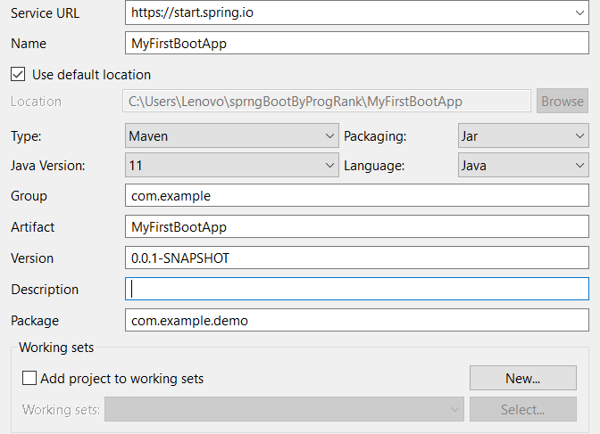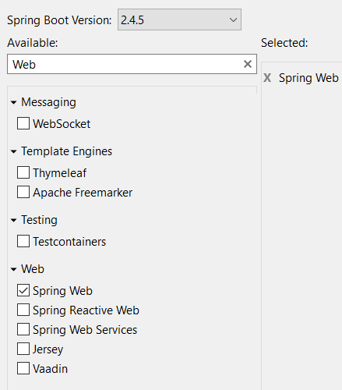

**JPA (Java Persistence API)**

It is an ORM tool which is used to connect with DB and perform CRUD Operation.

Spring-boot-stater-data-jpa is the dependency used in POM.xml

CRUDRepository or JPARepository interfaces are needed to be included. Internally JPARepository extends CRUDRepository i.e. CRUDRepository is superset of JPARepository.

JPA provides EntityManager Interface which enables us to perform CRUD operation.

JPA internally uses Hibernate.

In POM.xml we use “spring-boot-starter-data-jpa” dependency for using jpa.

Some Important Dependencies

1. Spring Web : for building restful applications
2. Mysql Driver: for using mysql.
3. Spring Data JAP : for connecting with database.

Note

@SpringBootApplication is combination of @EnableAutoConfiguration, @ComponentScan, @SpringBootConfiguration.

@SpringBootConfiguration :- It internally uses @Configuration.

@EnableAutoConfiguration :- Enable spring boot automatic configuration.

@ComponentScan :- Enable component scanning for those classes which are annotated with @Component, @service, @Controller.

All the dependencies of spring boot have a suffix “spring-boot-starter”. Eg Spring-boot-starter-web, spring-boot-starter-data-jpa, spring-boot-starter-test etc

META-INF/spring.factories is a jar which contains all the configurations that are required for spring boot project

Use Of webapp folder in src->main. Here we place all our jsp files.

By default h2 is disabled. To enable it use spring.h2.console.enabled = true in application.properties file

**Some properties used in APPLICATION.PROPERTIES**

Application.properties is used to setup configurations for spring boot application. Application.yml also does the same thing.

server.port=9090 (used to give a port number)

spring.mvc.view.suffix = .jsp

spring.mvc.view.prefix=/folder-name/

for database connectivity

spring.datasource.name=test

spring.database.url=jdbc:mysql://localhost:3306/test?serverTimezone=UTC

spring.datasource.username=root

spring.datasource.password=root

spring.datasource.driver-class-name=com.mysql.cj.jdbc.Driver

spring.jpa.properties.hibernate.dialect=org.hibernate.dialect.MySQL55Dialect

spring.jpa.hibernate.ddl-auto=update

Definitions

1. What is Spring boot : -

Spring boot is java based spring application framework used for Rapid application development for standalone micro services. In Spring we need to do a lot of configurations and add dependencies, Spring boot removes that configurations and dependencies.

1. How to change the port number of Spring boot application

In application.properties file we need to add server.port = “new port number”.

1. Can we replace the embedded tomcat-server

Yes.

1. How to use Properties defined in application.properties

We can use @Value

1. Difference between @RestController and @Controller

@Controller return data in form of HTML+CSS+Javascript Format (ideal for Web Applications) @RestController basically return data in json/xml format. Also controller+responsebody = rest controller

1. Difference between @RequestMapping and @GetMapping

@RequestMapping can be used with Get, Post, Put, Delete. Where as @GetMapping is only for Get.

1. For different Profiles how we do profiling(multiple application.properties)

We can use sping.profiles.active = dev/sit/prod.

Spring Boot questions

1. Can we add multiple controllers. 🡪 Hell Yes!!!
2. How to pass multiple value as path variable into api.
3. @PathVariable vs @Requestparam.